**Test Document for** **Export projects summary in HC/FC**

Testing on project – JB1014

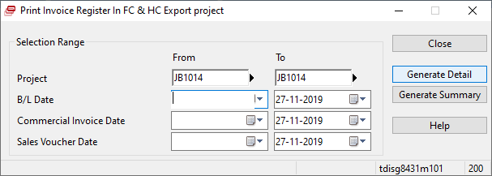

Result by Generate Details :

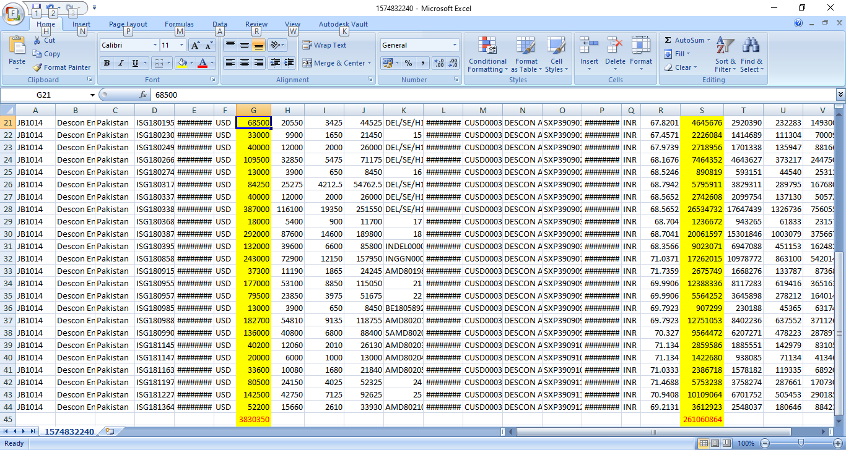

Result by Generate Summary :

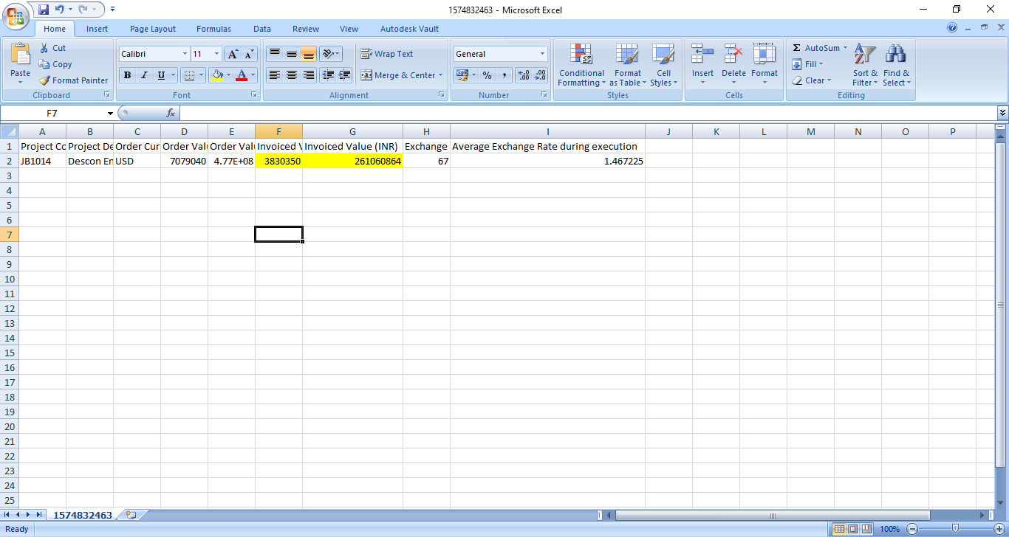

Result:

Total Amount of Invoice amounts of summary = total amount of invoice amounts of details